**EFFECT OF RELAXATION GUIDED IMAGERY ON PREMENSTRUAL SYNDROME IN ADOLESCENT**

**Hanna Sriyanti Saragih** 1

1) JurusanKebidanan Poltekkes Kemenkes Medan

Email: hana_riz@yahoo.com

ABSTRACT

Menstruasi adalah perdarahan secara periodik dan terjadi menurut siklusnya dari rahim. Nyeri menstruasi adalah nyeri saat menstruasi yang terasa di perut bagian bawah dan muncul sebelum, selama atau setelah menstruasi. *Relaksasi* Guided Imagery secara umum sebagai metode yang paling efektif terutama pada pasien yang mengalami nyeri sehingga perlu dilakukan penelitian pengaruh terapi relaksasi terhadap nyeri. Tujuan penelitian ini adalah untuk menganalisis perbedaan derajat nyeri menstruasi sebelum dan sesudah dilakukan relaksasi Guided Imagery.Penelitian ini merupakan penelitian kuantitatif dengan desain *quasi experimental* dengan *pre and post test control goup design* untuk mengetahui pengaruh relaksasi guided imagery terhadap nyeri menstruasi. Data dianalisa menggunakan uji Mann_Whitney, dan nilai *p*<0.05 dianggap bermakna secara statistik.Setelah dilakukan relaksasi guided imagery didapati hasil rerata nyeri menstruasi pada kelompok perlakuan sebesar 2,6 ± 0,5 dan rerata nyeri menstruasi pada kelompok kontrol sebesar 4,6 ± 0,6. Dari hasil penelitian dapat disimpulkan bahwa relaksasi guided imagery berpengaruh terhadap nyeri menstruasi.

Kata kunci: Pre-Menstrual Syndrom, Relaksasi, Guided Imagery

BACKGROUND

Premenstrual syndrome (PMS) is a cyclic recurrence of certain physical, psychologixal, and behavioral changes that begin during the week prior to menstruation (the luteal phase of menstrual cycle) and disapperar soon after menstruation has begun (Dickerson, 2003; Chrisler, 2015).

The PMS symptoms reported in the literature fall into three domains: emotional, physical and behavioral. The most common emotional and mood-related symptoms of PMS include depression, irritability, crying, over sensitivity (hypersensitivity) and mood swings with altervating sadness and anger. Physical discomforts include abdominal cramps, fatigue, bloating, breast tenderness and weight gain. Behaviorally symptoms include food cravings, poor concentration, social withdrawal, forgetfullness and decreased motivation (Thu, 2006).

Diagnostic criteria for PMS are at least one of the listed affective or somatic symptoms must be experienced during the 5 days before menses in three prior menstrual cycles and relieved with the menstrual flow. The symptoms should be confirmed by two cycles of prospective reports. The symptoms cause identifiable impairment in the patient's functioning and are not accounted for by other physical or emotional disorders. Symptoms consistent with PMS that may include: Affective symptoms: depression, angry outbursts, irritability, anxiety, confusion, social withdrawal. Somatic symptoms: breast tenderness, abdominal bloating, headache, swelling of extremities (ACOG, 2001).

Moe and Kotsirilos in poornima mention PMS has no established treatmenst, however, a few alternative forms of healing can be done. Owing to the fact that PMS‟s emotional symptoms consist of mainly mood swings, the usual treatments that clinicians and therapists prescribe are relaxation techniques (Poornima, 2015).

Guided imagery is one of relaxationtechnique, that focus on pleasant images, through storytelling or descriptions designed to suggest mental images (also called visualization) to replace negative or stressful feelings and relax (NCCAM, 2013).

Relaxation is more than a state of mind; it physically changes the way body functions. When body is relaxed breathing slows, blood pressure decrease and increase oxygen consumption, and some people report an increased sense of well-being. This is called the “relaxation response.” Being able to produce the relaxation response using relaxation techniques may counteract the effects of long-term stress, which may contribute to or worsen a range of health problems including depression, digestive disorders, headaches, high blood pressure, and insomnia (ACOG, 2006).

Relaxation is an independent intervention to reduce pain intensity, improve pulmonary ventilation and increases blood oxygenation. Skeletal muscle relaxation is believed to reduce pain by relaxing the muscles (Smeltzer, 2002).

It has been estimated from retrospective community surveys that nearly 90% of women have experienced at least one premenstrual syndrome (PMS) as defined by ICD-10 criteria (WHO, 1992).

In department of padangsidimpuan midwifery of Medan Health Polytechnic, estimated 35% student with more than two of premenstrual symtomps and about 5% can not do usual activities due to the symptomps. The symtomps are like crying, hypersensitivity, abdominal cramp, decreased motivation, and food craving. So the aim of this study is to analyze the effects of guided imagery to reduce premenstrual syndrome.

METODE

A quantitative paradigm was used in the study. A quasi-experimental design which involves both pre-test post-test control group design, an experimental group was used to study the effect of the intervention on premenstrual syndrom and no intervention in control group. The sample chosen for the study was 32 female college students in the age group of 18 to 22 years with more than two symptoms of premenstrual syndrom. Sample size by Sastroasmoro formula with the value of SD from previous study is 1,17. 16 participants were assigned to the intervention group and 16 to the control group. The sample was chosen based on convenience sampling by approaching college students from Padangsidimpuan midwifery academy that showed symptoms of premenstrual syndrom based on observation form.

Data collection instrument was a questionnaire. The Shortened Premenstrual Assessment Form by Allen, McBride and Pirie (1991) was used for the basic screening of participants to see if they experienced any significant premenstrual symptoms and Premenstrual Daily Symptom Diary by Dickerson (2003) was used to record participants daily experience of symptoms.

College students of Padangsidimpuan midwifery academy were approached by the researcher for participation in the study through interview. Female students were asked whether they experienced symptoms of premenstrual syndrom in relation to their menstrual cycle, and than filled the SPAF to know their score. These students were given Premenstural Daily Symptom Diary (PDSD) to identified their symptoms of premenstrual syndrome. The participants were enrolled for the study based on their symptoms of premenstrual syndrom. 32 participants with more than one symptoms of physical, psychologixal, and behavioral of premenstrual syndrom were be selected and 16 participants were assigned to the intervention group and 16 to the control group respectively. Participants with same cycle (25 days until 35 days) and whose menstrual phase fell around the same time of the month were included so that the intervention can be given accordingly. Informed consent was be obtained from the participants. The researcher gave the participants the guide to do guided imagery and teach them until they can do it by themselves. The intervention consisted of the participants doing guided magery 15 minutes a day by 7.30 o’clock in the morning. The participants recorded their symptoms of premenstrual syndrome in the Premenstrual Daily Symptom Diary (PDSD) form through one menstrual cycle and at the end of one month, they were given the SPAF. The control group was not given any intervention. However they completed the PDSD form and SPAF. Paired sample t-test was used to compare the pre-test and post-test data.

RESULT AND DISCUSSION

**Results**

Table 1 showing the characteristic of the intervention group and control group

|  |  |  |  |
| --- | --- | --- | --- |
| Characteristic | Intervention Group  Mean±SD | Control Group  Mean± SD | *Sig* |
| Age | 18,7 ±1,0 | 18,7 ± 0,5 | *p>0,05* |
| Age of Menarche | 13,0 ± 1,1 | 13,5 ±1,2 | *p>0,05* |
| Score SPAF | 32,8 ± 1,4 | 33,1 ± 1,4 | *p>0,05* |
| Score PSDS | 528,6± 9,5 | 526,5± 7,3 | *p>0,05* |

There is no significant difference of characteristics between the the intervention group and control group.

Table 2 showing the results of t_ test of post-test total score of guided imagery between intervention group and control group on SPAF Score

|  |  |  |
| --- | --- | --- |
| SPAF Score | Mean ± SD | *p* |
| Intervention Group  Control Group | 19.4 **±** 1.9  33.1 **±** 1.4 | 0.001 |

There is a significant difference between the intervention group (M=19.4 **±** 1.9) and control group (M= 33.1 **±** 1.4) on the post-test of guided imagery on the SPAF Score; p = 0.001.

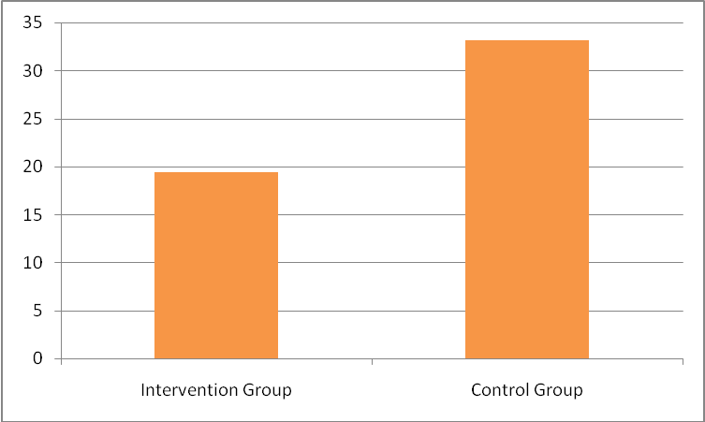

figure 1. Mean of SPAF Score post test between intervention group and control group.

*Table 3 showing the results of mann_whitney test of post-test total score of guided imagery between intervention group and control group on PDSD Score*

|  |  |  |
| --- | --- | --- |
| *PDSD Score* | Mean ± SD | *Sig* |
| Intervention Group  Control Group | 426,9 ± 17,1  526,5 ± 7,3 | 0,001 |

There is significant difference between the intervention group (M=426,9 ± 17,1) and control group (M= 526,5 ± 7,3) on the post-test of guided imagery on the PDSD Score; *p* = 0.001.

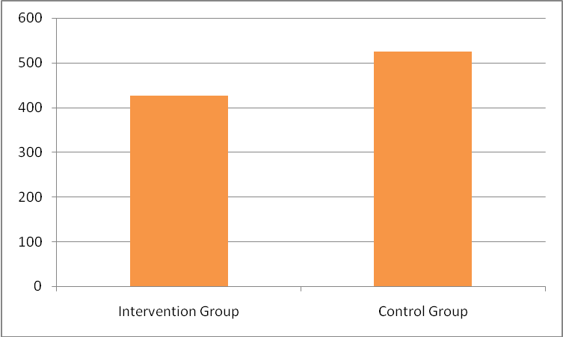

figure 2. Mean of PDSD Score post test between intervention group and control group.

**DISCUSSION**

The purpose of the present research was to study the effectiveness of guided imagery on the premenstrual syndrome. The results of the study indicate that guided imagery has had a significant effect on the intervention group, leading to a reduction in the symptoms of premenstrual syndrome.

Table 1, 2 and 3 shows that the pre-test scores of the participants in the intervention group on SPAF and PDSD Score are higher than the post-test scores, indicating a reduction in the severity of premenstrual syndrome’s symptoms after the intervention. The post-test scores between the intervention group is lower compare to the control group and with the t-test, statistically siginificant. Based on this, the hypothesis which states that there is significant difference in the SPAF and PDSD Score of the participants in the intervention group compare to control group is accepted.

Hence, based on these results, a conclusion can be drawn that guided imagery has a significant effect on the reduction of severity in symptoms of premenstrual syndrome. Guided imagery statistically significant decreases in stress, fatigue, pain, anxiety and depression, improve physical function, as wll as to enhance a sense of self efficacy for managing symptoms related to chronic pain condition (Menzeis, 2014). Arias in Poornima said that meditation techniques have an effect on different illnesses, including premenstrual syndrome (Poornima, 2015). ACOG recommendations for reduction of PMS symp­toms include exercise, relaxation techniques, rich com­plex carbohydrate and low sugar diet, low fat and salt diet, and emotional support (Arab, 2015).

Previous study showed that menstrual distress coping education program that include relaxation can be effective for decrease menstrual distress (Choi, 2015). Relaxation influence hormones adrenaline and cortisol that causes stress will decrease. In the relaxed condition, the body will stop the production of adrenaline hormones and all hormones that is required when stress occured. Because of the sex hormones (estrogen and progesterone) and the stress hormone (adrenaline) are produced from the same chemical building blocks, when we reduce stress then will reduce the production of the sex hormone (Potter and Perry, 2005).

Practice of meditation like guided imagery leads to the relaxation response, which is a set of pyhsical changes that include increased blood flow to the brain and release of muscle tension (Gurung, 2014). That will decrease abdominal cramp due to symptoms of premenstrual syndrome. Benson’s relaxation response in Kegel 2014 showed changing thought patterns through meditation, impact on the subjects, that decreased metabolism, respiration, and heart rates, and had slower brain waves. This relaxation also effective in premenstrual syndrome (Kegel, 2014).

**CONCLUSION**

Thus, it can be concluded from the results of the present study that guided imagery has a significant effect in reducing the menstrual pain (dysmenorrhoea).

REFERENSI

ACOG, 2006, Menstruation in girls and adolescents: using the menstrual cycles as a vital sign. ACOG Committee Opinion Number 349, 2006.

Alimul A. 2006. *Pengantar Kebutuhan Dasar Manusia*. Surabaya: SalembaMedika.

Eman, 2012. *Epidemiology of Dysmenorrhea among Adolescent Students in Assiut City, Egypt.* Life Science Journal; 9(1).

National Center For Complimentary and Alternative Medicine (NCCAM), 2013. *Relaxation Techniques For Health*. US. NIH.

Novarenta A, 2013. *Guided Imagery Untuk Mengurangi Rasa Nyeri Saat Menstruasi*. Jurnal Ilmiah Psikologi Terapan. ISSN: 2301-8267 Vol 01, No.02 Agustus, 2013. Fak Psikologi Univ.Muhammadiyah Malang

Perry, AG, Potter PA .2005. Buku Ajar Fundamental Keperawatan;Konsep, Proses dan Praktik , Vol.2 Alih Bahasa. Editor Monica Ester Dkk, Jakarta : EGC

Poornima, 2015. *The Effects of Classical Music based Chakra Meditation on the Symptoms of Premenstrual Syndrome.* The International Journal of Indian Psychology ISSN 2348-5396 (e) | ISSN: 2349-3429 (p) Volume 2, Issue 3.

Priharjo, R. 2003. *Perawatan Nyeri*. Jakarta. EGC

Sastroasmoro S. 2011. Dasar-dasar Metodologi penelitian klinis. Jakarta: CV.Sagung seto.

Smeltzer & Bare 2002. *Keperawatan Medikal Bedah*. Edisi 8. Vol 1. AlihBahasa Agung Waluyo. Jakarta. EGC

Sigit NP. 2010. *Konsep dan Proses Keperawatan Nyeri*. Edisi 1.Graha Ilmu. Yogyakarta

Tamsuri A, 2007. *Konsep dan Penatalaksanaan Nyeri*. Jakarta. EGC

Wirya I, Sari MD, 2013. *Pengaruh Pemberian Masase Punggung Dan Teknik Relaksasi Nafas Dalam Terhadap Penurunan Intensitas Nyeri Pada Pasien Post Appendiktomi Di Zaal C Rs HKBP Balige Tahun 2011*,Jurnal Keperawatan HKBP Balige, Vol.1 No.1, Juni 2013 ISSN 2338-369091